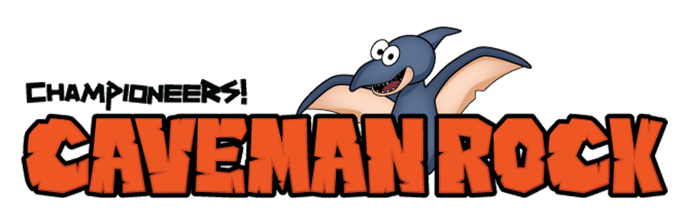

Week #6

Dear Families:
This week in music class, we learned more about the invisible force of peer pressure. In our story, Al-x is faced with the decision to tell the truth about not catching the prize-winning fish, or letting everyone believe the lie that he did. Al-x wants everyone to like him, and is worried that if he tells the truth, the other cavemen won’t like him anymore. Sometimes students feel an invisible pressure to act a certain way, or do something, even lie, just so others will like us.

We learned that other things respond to invisible forces too, like our own hair! Try this experiment, and see how strong static electricity can be, even though it’s invisible!
Enjoy,
Teacher’s Name
Music Teacher, Name of Your School

____________________________________________________________________________________
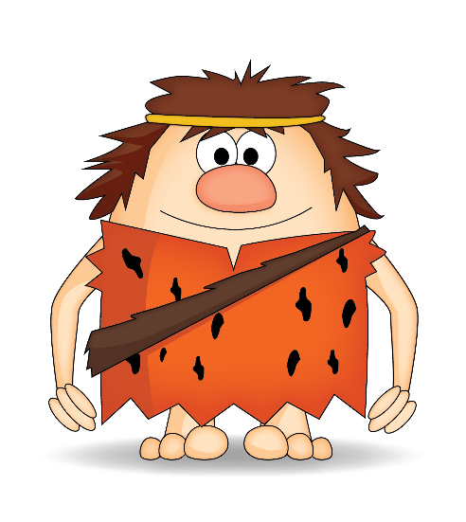
Static Electricity

Directions: Blow up a balloon and rub it on your hair. Watch how your hair stands up and sticks to the balloon because of static electricity! Have fun!

For more Championeers! Family Night resources go to: www.championeersfamilynights.com

