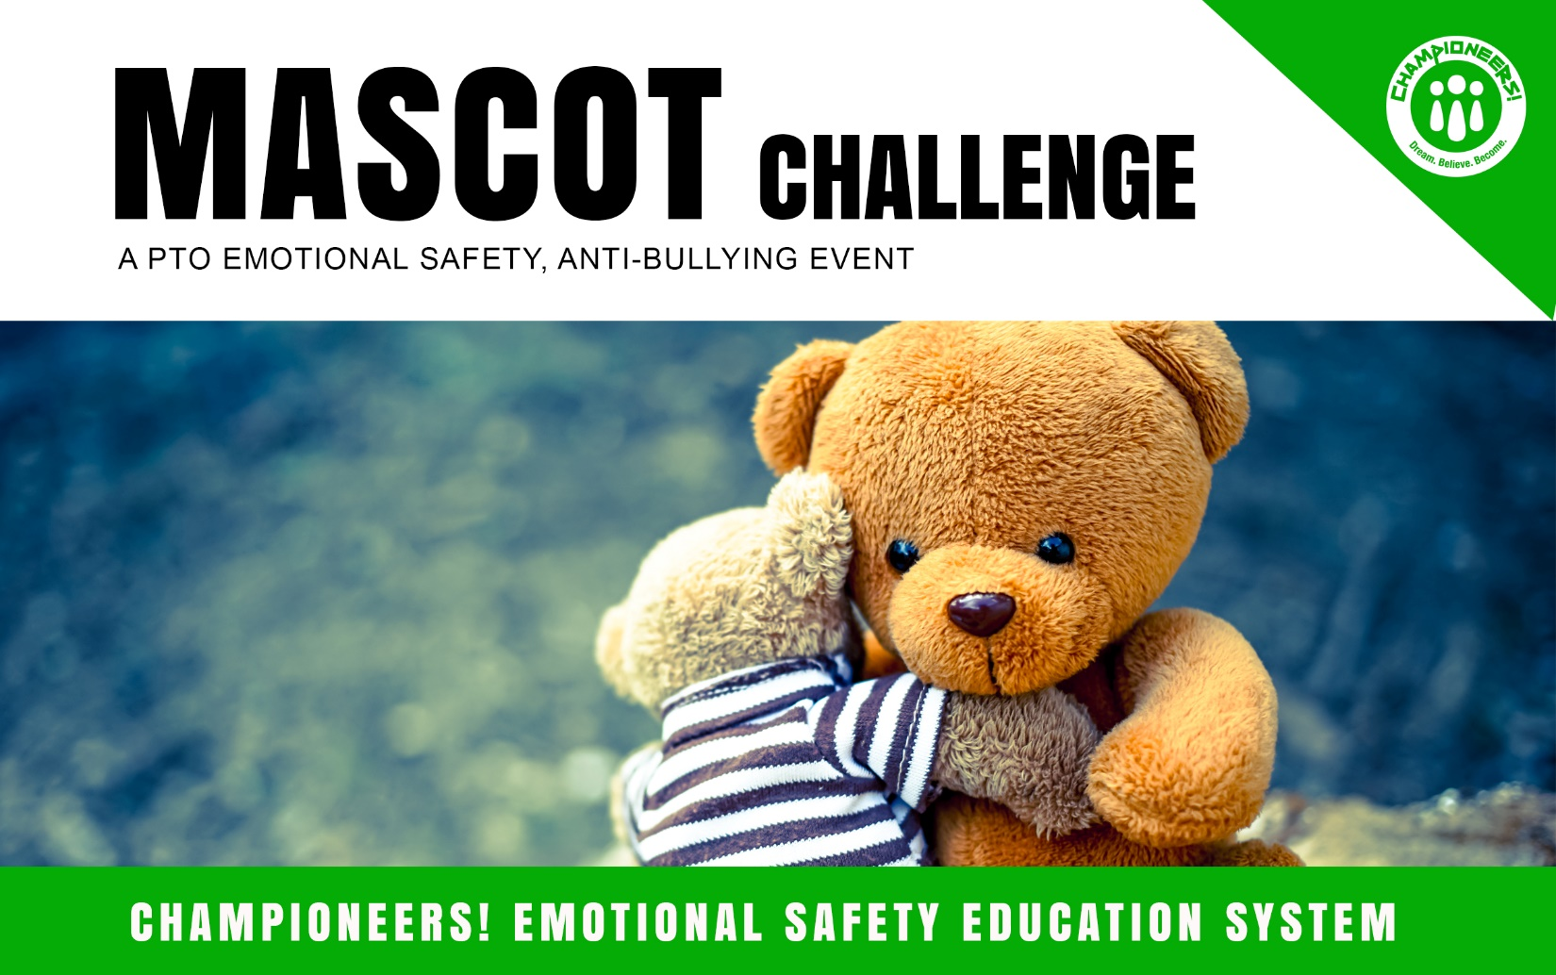
Hey There Staff!
This Happy, Healthy School event proves, once again, that some of the simplest things have the greatest impact. To inspire great choices, we’ll reward positive habits through a friendly competition between classes. The winning class each week will be awarded our school mascot to host in their class for one week, bragging rights, their class picture with our mascot posted on the Bragging Board (bulletin board) and ice cream! (feel free to edit your awards any way you’d like.) Here’s how you win. The classroom that achieves the highest points on the following matrix each week wins! Just keep track of your points throughout the week, submit at the end of the day each Friday and we’ll announce the winner during the Monday morning announcements! This competition will only take place for the next 4-8 weeks (Confirm how long. A limited time period is best, then change it up and repeat each year.) so let the games begin!

Have Fun!

Sponsored by your PTO
GREAT SCHOOLS ARE EMOTIONALLY SAFE!
A gift from the Championeers! Emotional Safety Education Grant. For more resources go to: Championeers.com |© 2019

MASCOT POINTS
(This list should be made in conjunction with any PBIS programs you currently have in place.)

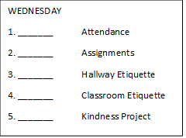
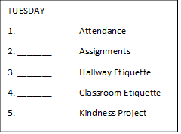
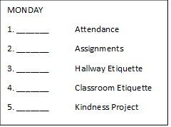

WEEKLY TALLY
1. _______ Attendance
2. _______ Assignments
3. _______ Hallway Etiquette
4. _______ Classroom Etiquette
5. _______ Kindness Project

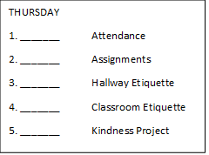

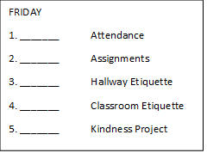

Sponsored by your PTO
GREAT SCHOOLS ARE EMOTIONALLY SAFE!
A gift from the Championeers! Emotional Safety Education Grant. For more resources go to: Championeers.com |© 2019

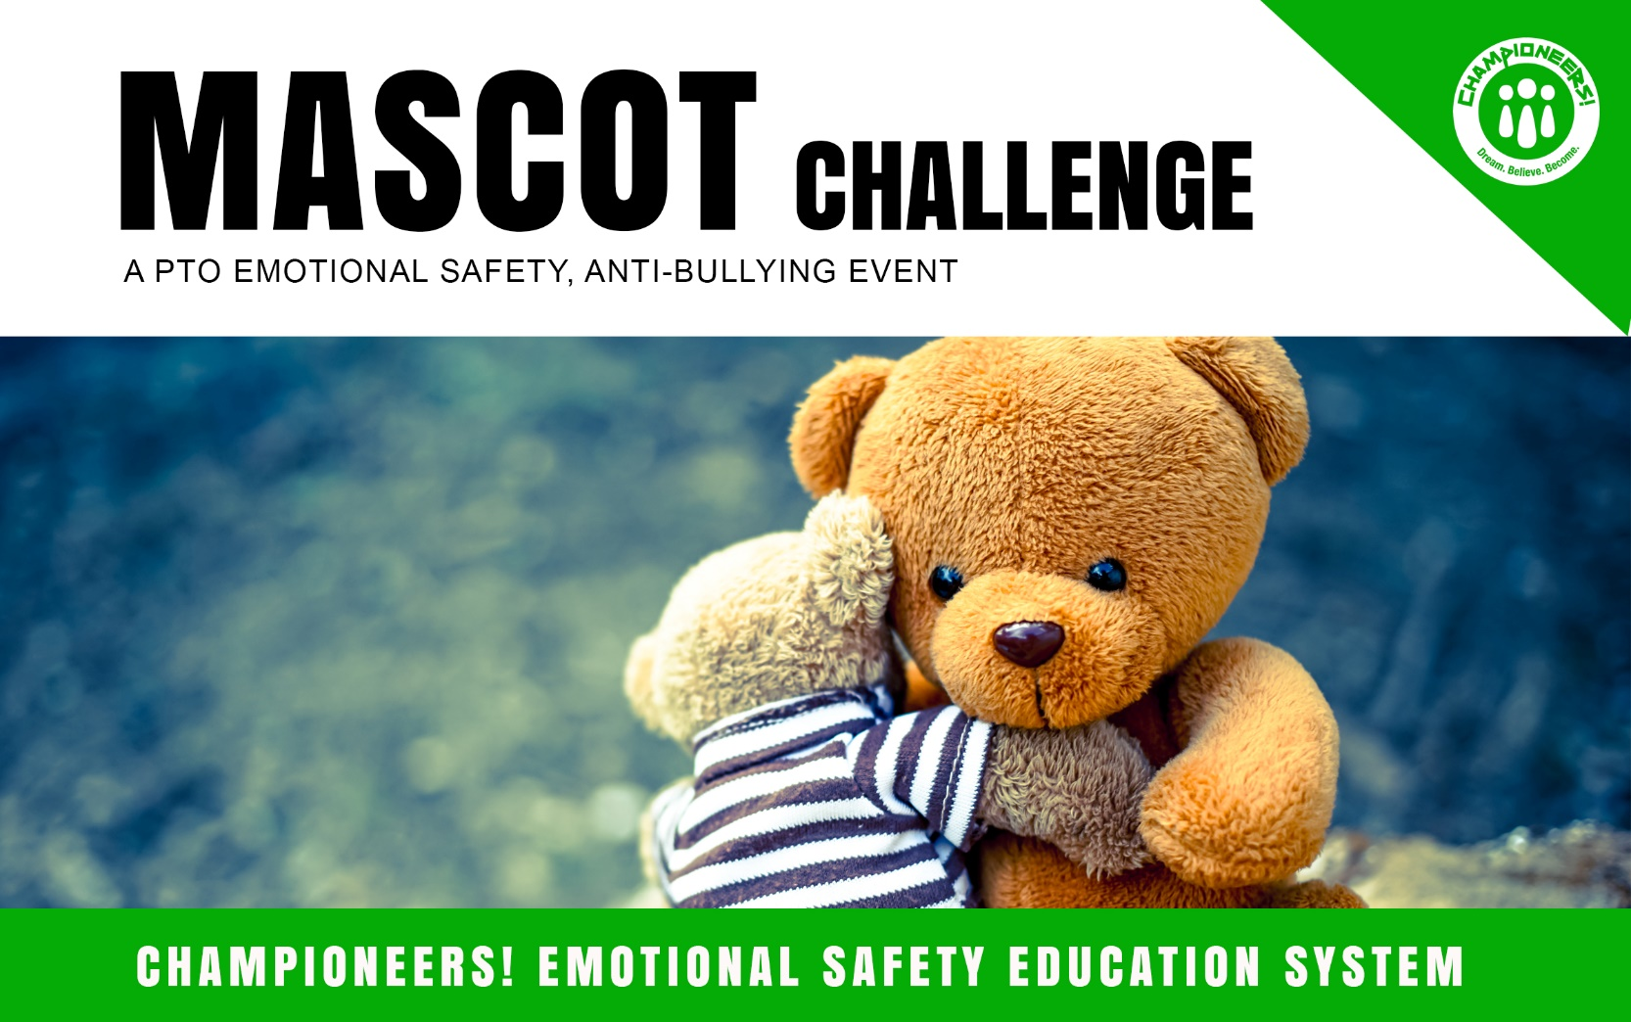
EVENT CHECK-OFF LIST
____ Planning & Permission
____ Admin Approval
____ Facilities & Dates
____ Marketing & Teacher Notes (edit, copy and paste info in the teacher notes and announcements.)
____ Supplies
____ Set-Up
____ Clean-Up
____ Thank You Notes
____ Pics Posted to your PTO Facebook and to Championeers! Facebook
with #happyhealthyschools, #championeers, #bullying, #schoolevents, #PTO, etc. (Thank you)
____ Share with another mother (or father) for another school!
A gift from the Championeers! Emotional Safety Education Grant. For more resources go to:
Championeers.com |© 2019

