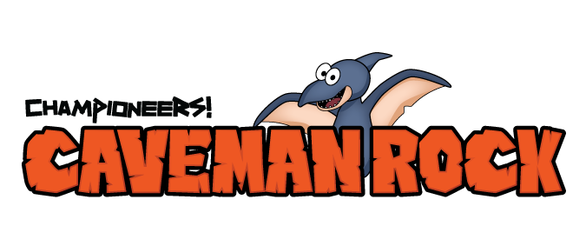

Dear Families:

I’m excited to announce our school has received a grant for Emotional Safety Education (ESE) that helps eradicate the root causes of bullying and other critical youth issues through the performing arts. Caveman Rock is a phenomenal, anti-bullying production that teaches students how to deal with peer pressure and self-worth, right through the delightful musical story of Alex and his cavemen friends.

What’s really exciting is there’s a family component that puts you in the driver’s seat. Each week you’ll receive an optional STEM-type activity that coordinates with the lesson. Not only do they provide fun family-time activities, they are an excellent launching pad to discuss these concepts with your children through your family’s unique values and belief systems.

Enjoy,

Teacher’s Name  
Music Teacher, Name of Your School

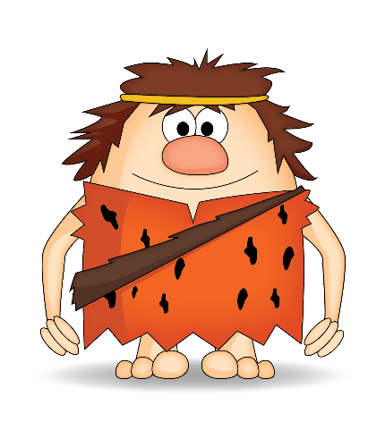

“I’ll be me and you be you and   
that’s what makes us rock!”