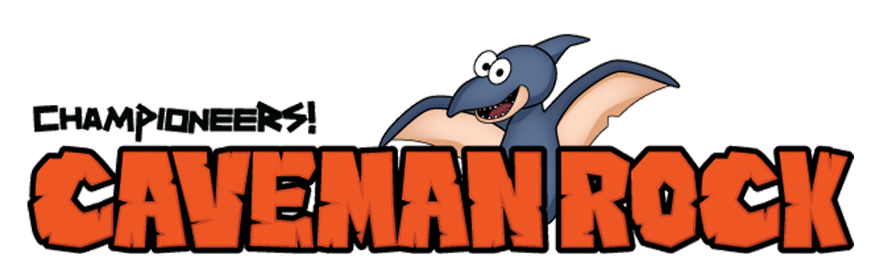

Week #2

Dear Families:
This week in music we learned about conformity. We learned that you are the best you in the whole world, and we don’t need to be anything but our very best selves! Here is the recipe for Dino-Dough. Be sure and ask your children what copy-cats, chameleons, and dino-dough have to do with peer pressure and conformity.
Enjoy,
Teacher’s Name
Music Teacher, Name of Your School

____________________________________________________________________________________
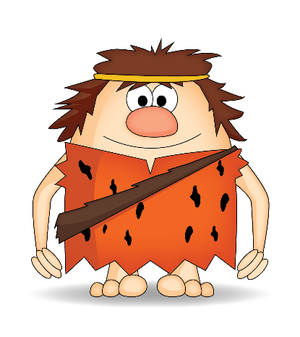
Caveman Rock Dino-Dough

Ingredients: Large mixing bowl, 1½ cups water, 4 cups flour, ½ cup cooking oil,
1½ cups Salt, food coloring
Directions: Pour water into bowl, add food coloring, add all dry ingredients, add oil, Mix together. Have fun!
Secret Ingredient: Roar in your bowl like a dinosaur to make it really special!
For more Championeers! Family Night resources go to: www.championeersfamilynights.com

