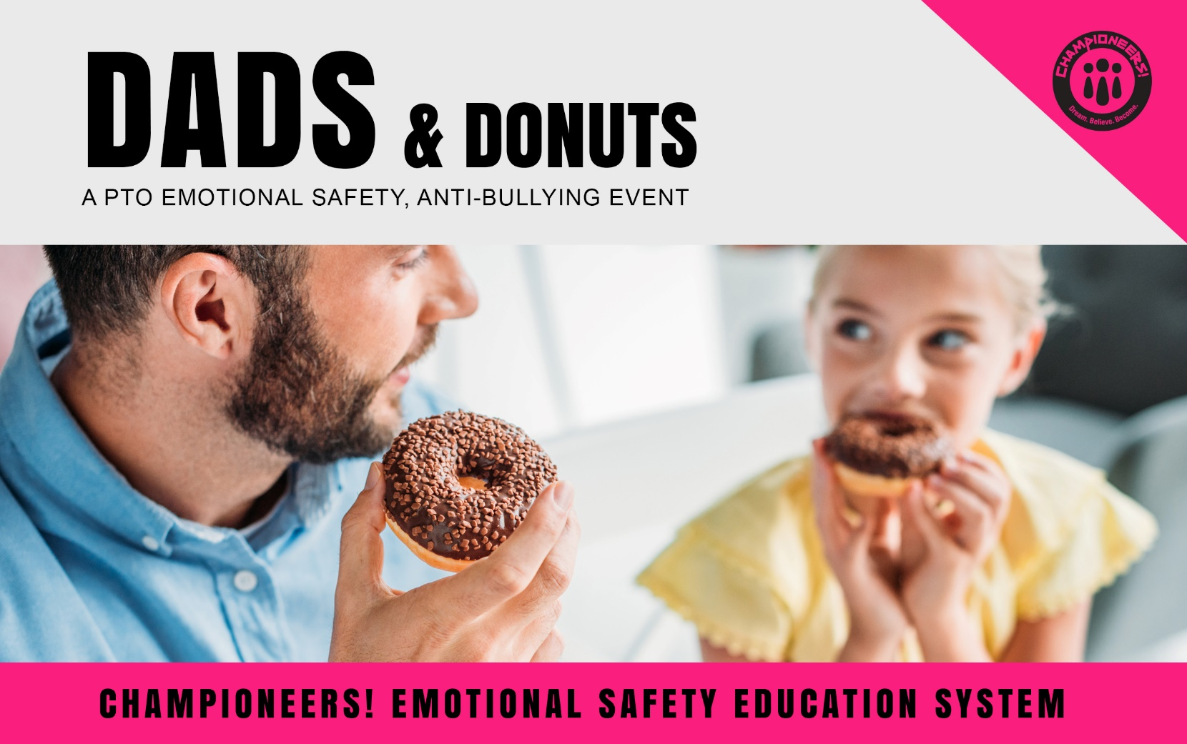

**WHAT: A Happy, Healthy School Event for…** students and their dads, grandpas, and role models to enjoy donuts and coffee/hot cocoa before school.

**WHEN:**

**WHERE:**

**COST: FREE**

Sponsored by your PTO  
**GREAT SCHOOLS ARE EMOTIONALLY SAFE!**A gift from the Championeers! Emotional Safety Education Grant. For more resources go to:   
Championeers.com |© 2019

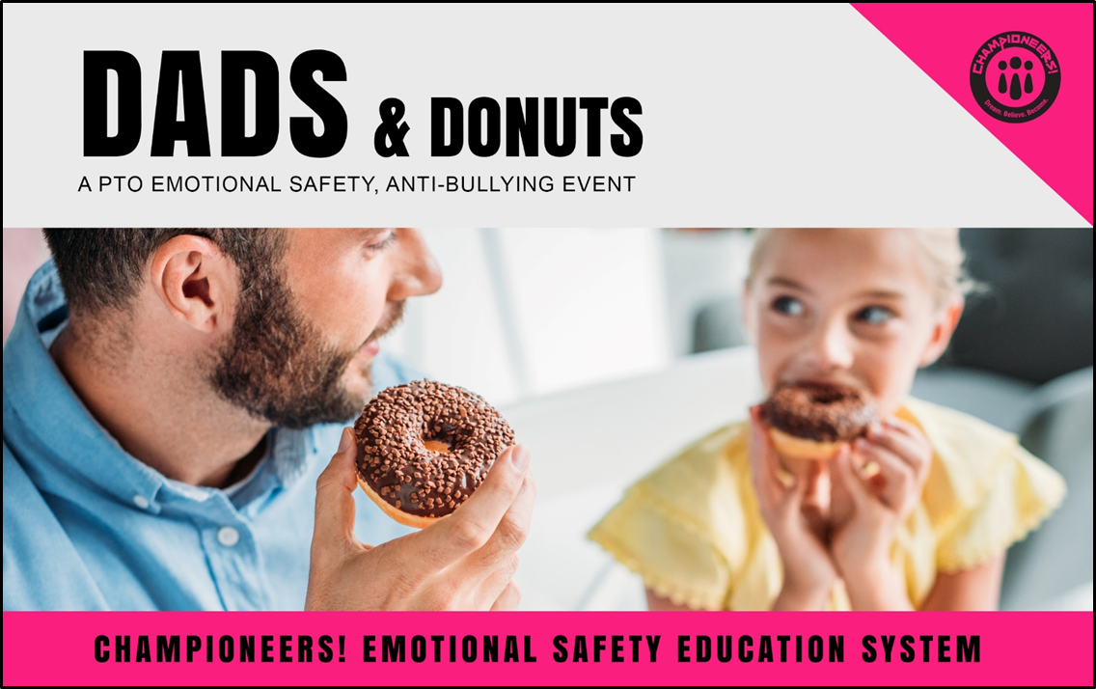

**EVENT CHECK-OFF LIST**

____ Planning & Permission

____ Admin Approval

____ Facilities & Dates

____ Marketing & Teacher Notes (copy and paste description for parent/teacher notes and announcements.)

____ Supplies

____ Set-Up

____ Clean-Up

____ Thank You Notes

____ Pics Posted to your PTO Facebook and to Championeers! Facebook   
with #happyhealthyschools, #championeers, #ESE (Thank you)

____ Share with another mother (or father) for another school!

A gift from the Championeers! Emotional Safety Education Grant. For more resources go to:   
Championeers.com |© 2019