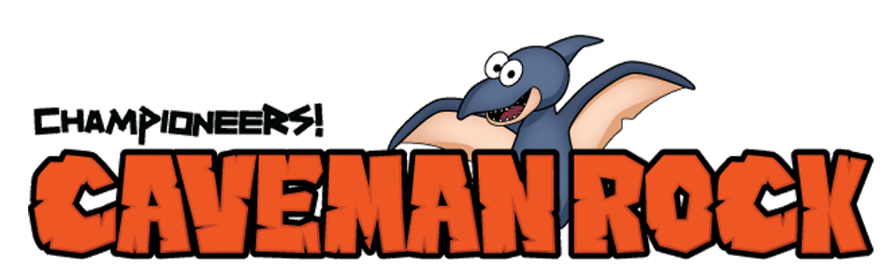

Week #7

Dear Families:
This week in music class, we saw how quickly Al-x’s head puffed up with his new popularity and how disrespectful he was to his parents, now that he’s so “cool!” We’re hoping Al-x will figure out that lying and pretending to be something he’s not, actually robs his friends of the real Al-x that they already like.

Here’s an easy experiment that you can do at home to see how easy it is for anyone to get a big head if we are not grounded in who we really are. Think of the vinegar as your self-esteem, or ego. It’s neither good or bad, it’s just there echoing to us whatever we tell it. Think of the soda as our pride. When pride hits our ego it can tell us that we are better than other people. As you’ll see in the experiment, the reaction causes the balloon to inflate. That’s what we can do if we don’t harness our sense of accomplishment into paths of empowerment that help others succeed with us. This week’s lesson brings up lots of fun topics to discuss at home, and possibly some hidden pride spots that we all need to work on! Lots of food for thought.

Enjoy,
Teacher’s Name
Music Teacher, Name of Your School

____________________________________________________________________________________
Self-Inflating Balloon

Directions: Fill an empty water bottle ½ way with vinegar. Next, fill a regular size balloon ½ way with baking soda. Wrap the mouth of the balloon over the top of the water bottle. When you’re ready, pour the contents of the balloon into the water bottle. Watch the balloon fill up with air! Have fun!

For more Championeers! Family Night resources go to: www.championeersfamilynights.com
For lots of fun stuff go to: www.cavemanrock.com

