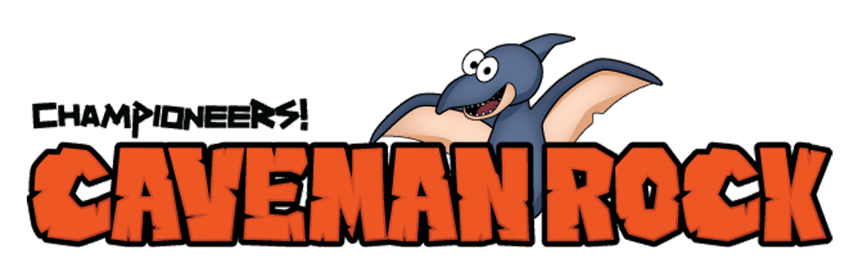

Week #10

Dear Families:
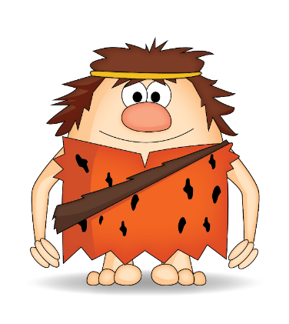
This week in music class we found Al-x still struggling with his decision to tell the truth about the fishing derby. He’s afraid his friends won’t like him when they find out he didn’t really win. The truth is, he’s good at many things, but not fishing, so his real question should be why he wants to impress people by being something he’s not? While Al-x continues to ponder what he should do, try this experiment at home to demonstrate what happens when we make decisions without good information to guide our choices.

Enjoy,
Teacher’s Name
Music Teacher, Name of Your School
____________________________________________________________________________________
Balloon Darts!
Directions:

- Blow up a balloon, don’t tie it – just pinch the end so the air does not escape.
- Stand about 20 feet from a small target.
- Take aim and let go of the balloon.

Did you hit the target or did the balloon swirl out of control? It’s hard to know what to do when we have to make decisions without good information, or how our decisions will affect our future. Discuss with your children how to find information to make wise choices. Encourage them to come to you first! It may be a good time to discuss your family’s core values and how they influence your decisions. Safe discussions during family night make it easier for your children to come to you when they have big issues. Have fun!

For more Championeers! Family Night resources go to: www.championeersfamilynights.com

